Sequence Diagram  
( DormNest – Student Accommodation Finder )

Parameshwaran K – 2022503509

Pavithran S – 2022503705

Inbavanan K - 2022503507

**Module Wise Sequence Diagram**

**Registration:**

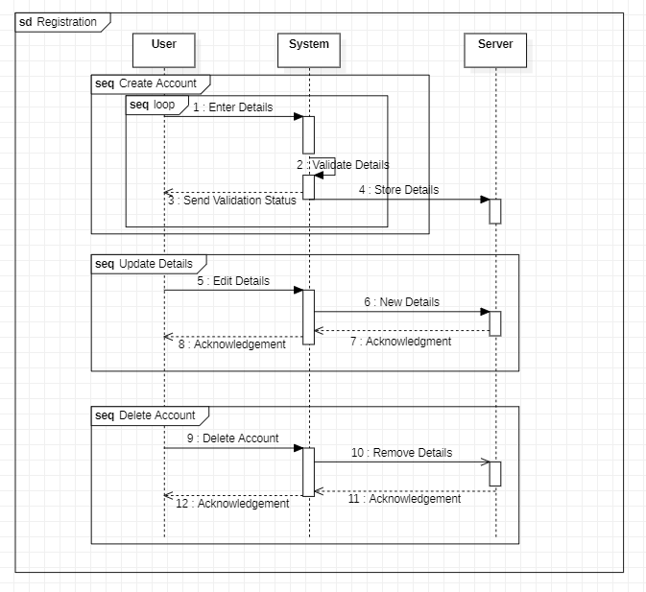

**Handle Property:**

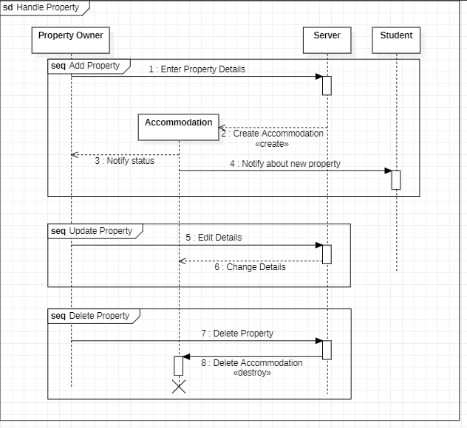

**Search & Apply:** 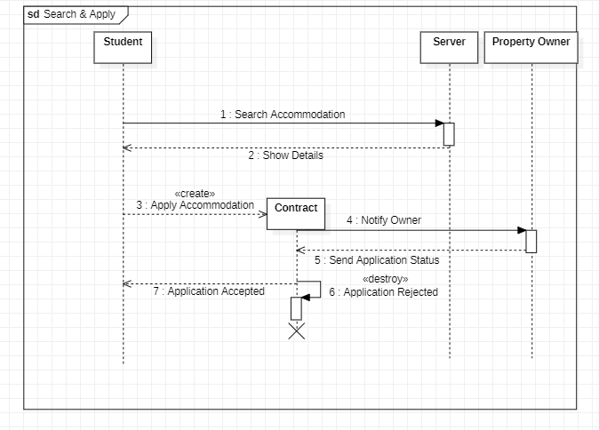

**Route to Property:** 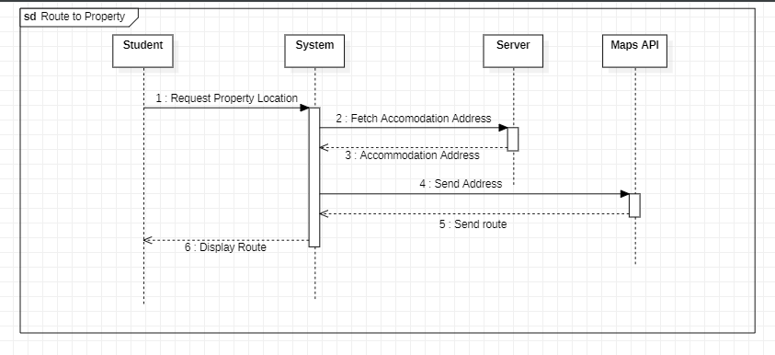

**Roommate Matching:**

